Design and Simulation of a PID with Anti-Windup ABS Controller for Vehicle Stability

Alexis Lechuga de los Santos

Andre Alberto Contreras Rivera

October 20th, 2021

# Introduction

The challenge of this project is to design and implement a simple anti-lock braking control, better known as ABS (Antilock Braking System). ABS braking systems have many advantages and benefits. Many of the vehicles currently on the market contain advanced ABS braking systems, which tend to be very complex. However, this project is focused on a specific and simple objective.

The control will be able to use only the signals provided by the sensors that are presented below:

* Pressure sensor in the master cylinder.
* An angular velocity sensor on each wheel.
* Inertial Measurement Unit (IMU, for its acronym in English).

## Block Diagram

An anti-lock braking system was designed, which is described in detail in the block diagram shown in figure 1.

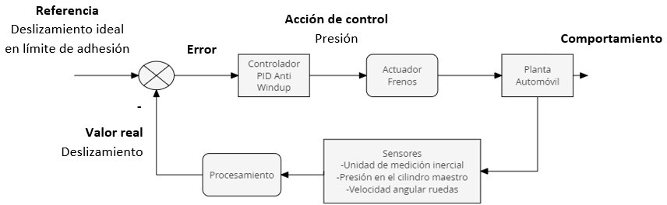

Figure 1: Block diagram of the system

# Design Decisions

## General operation of the system

The first decision made regarding the design of the system was the variable to control, opting to control the slipping of each of the wheels to increase the vehicle's traction on the road and especially to prevent the wheels from locking or skidding, thus improving the braking parameters of the vehicle.

Likewise, we selected the pressure exerted on each of the brake calipers as the variable to manipulate and decided to monitor the sensor values for each of the wheels separately and also to generate a specific control action for the pressures of each of the brake calipers.

* 1. **Reference Slip Value**

In order to reduce the braking time and distance, it is desired for the adhesion of the wheels to the road to be as high as possible, and given that, the value the point of sliding where this maximum adhesion occurs is at the limit of the transition between adhesion and complete sliding of the wheel (preventing it from locking), we locate our reference of sliding just before this limit.

For the selection of the specific value, we tested the system's performance with different slip values from 0.15 to 0.25, with an interval of 0.05, finding that in our case the best performance occurred with a slip of 0.2, a value that approximately matches the location of smax in the slip graph with respect to the force shown in figure 2.

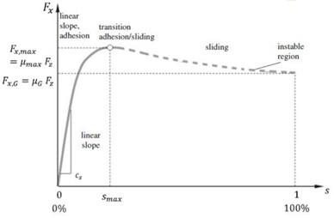

Figure 2: Graph of the sliding with respect to the force.

## Slip Monitoring

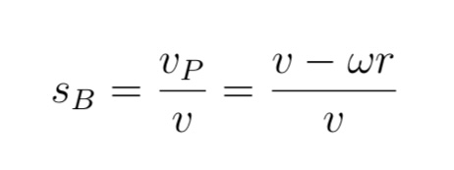To obtain the slip, we decided to use the formula for a wheel being braked, where the difference between the longitudinal speed and the tangential speed derived from the angular velocity of the wheel multiplied by its radius is divided by the longitudinal speed.

The acquisition of longitudinal velocity was based on the approximation to the integral of longitudinal acceleration provided by the inertial measurement unit, an approximation that was carried out using Riemann sums, where the sum of the rectangles formed in the area under the curve is made, taking the sampling time T as the base of each rectangle and the value of longitudinal acceleration at that iteration as the height.

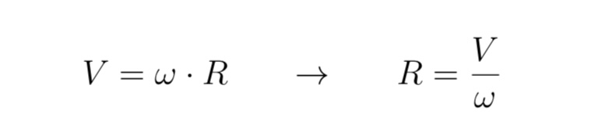To obtain the radius originally and what would happen if the vehicle model were not available or the dimensions of the wheels were not known, we consider that moments before braking, ideal conditions are met where it can be assumed that the longitudinal speed is equal to the tangential speed of the wheel, so the value of the radius can be approximated by isolating it from the following formula.

Adding that preferably the angular velocity value of the wheels should be taken at the axes where the vehicle has traction, since they will more closely resemble the behavior of the wheels in pure rolling.

But later, when investigating the blocks of the vehicle model, we found that the radius could be obtained from a constant K, in a segment where this same relationship was carried out where the longitudinal speed is equal to the tangential speed of the wheel.

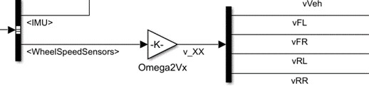

Figure 3: Diagram of the wheel sensors in Simulink.

## Control Mechanism

For our system, we decided to use a PID controller with anti-windup effect as a control mechanism, whose form is based on the traditional PID but adds a closed loop to prevent the saturation of the integrative action, thus considering the errors and control actions from previous iterations. The block diagram is shown in figure 4.

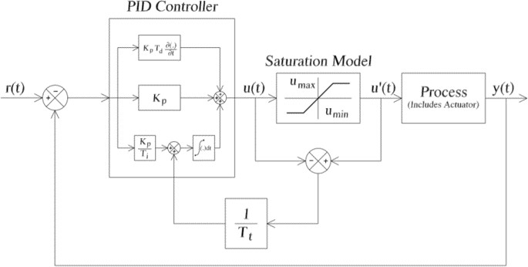

Figure 4: Block diagram of the anti-windup PID controller.

Our controller is powered by the error, which is obtained from the difference between the reference slip value and the actual slip value calculated for each wheel, since the control algorithm we use has the following form:

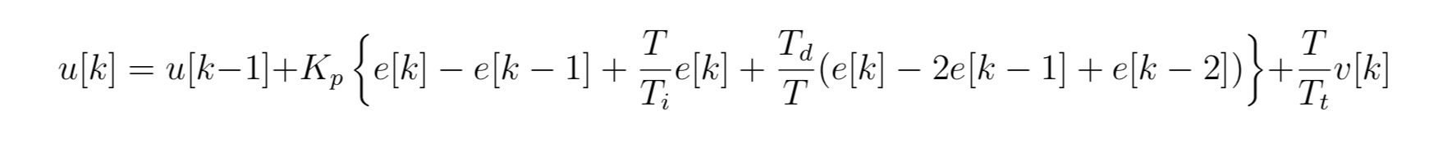

To obtain the control action for each iteration, it is necessary to consider the errors and control actions from previous iterations, relating to the constants Kp, Ti, and Td.

Furthermore, the decision to use this controller, including the anti-windup effect, comes from the goal of avoiding saturation of the actuators in the face of values required by the control action that exceed preset values or physical capacities, which is why conditions were programmed in our program to limit the control action ensuring that the maximum was a one-to-one relationship with the pressure on the master cylinder.

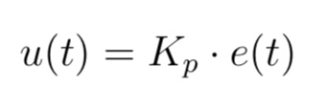

* Proportional action:

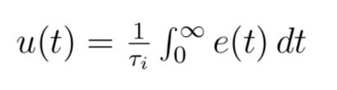

* Integral action (Reset):

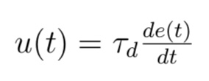

* Derivative action (Prediction):

Finally, for the selection of the constants Kp, Ti, and Td that exert the proportional, integral, and derivative actions respectively, a sweep was performed to check the system's performance under different tests, selecting the values from the attempts with the best results while also taking into account, as will be explained later, the compliance with all the requirements with those values.

# Progress Tables

To verify the operation of our controller, three different validation tests were carried out; in each one, it is expected that the vehicle does not leave the lane, that is, it has a constant turning. For each test, five attempts were made with different values highlighting the best three to be graphed in the following section.

## InitPanic90.m

In this validation test, a panic brake is performed (the brake pedal is pressed down fully) at an approximate speed of 90 km/h, on a homogeneous surface [= 09]. The progress is shown in Table 1.

|  |  |  |  |  |  |
| --- | --- | --- | --- | --- | --- |
| **Progress - Case 1** | | | | | |
| Initial Speed: 88-92 km/h km/h Brake input: 1 | **T1** | **T2** | **T3** | **T4** | **T5** |
| Controller | No | S´ı - PID | S´ı - PID | S´ı - PID | S´ı - PID |
| Braking time (sec) | 7.145 | 4.87 | 4.255 | 4.14 | 4.04 |
| Stopping distance (m) | 99.69 | 68.74 | 56.95 | 52.74 | 48 |
| Slip target | - | 0.2 | 0.2 | 0.2 | 0.2 |
| Kp | - | 1.8 | 1 | 0.9 | 0.8 |
| Ki | - | 1.5 | 0.5 | 0.3 | 0.08 |
| Kd | - | 0 | 0 | 0 | 0 |

Table 1: Progress of the test Init Panic90.m

## InitLightAndPanic70.m

In this validation test, a light brake and sudden panic brake (the brake pedal is applied lightly and without releasing the pedal, then applied fully) is performed at an approximate speed of 70 km/h, on a quasi-homogeneous surface [= 093;088;081;086 (FL; FR; RL; RR)]. The progress is shown in Table 2.

|  |  |  |  |  |  |
| --- | --- | --- | --- | --- | --- |
| **Progress – Case 2** | | | | | |
| Initial Speed: 68-72 km/h Brake input: 1 | **T1** | **T2** | **T3** | **T4** | **T5** |
| Controller | No | S´ı - PID | S´ı - PID | S´ı - PID | S´ı - PID |
| Braking time (sec) | 6.075 | 4.905 | 4.94 | 4.55 | 4.39 |
| Stopping distance (m) | 72.66 | 61.98 | 62.08 | 60.16 | 48.39 |
| Slip target | - | 0.2 | 0.2 | 0.2 | 0.2 |
| Kp | - | 1.8 | 1 | 0.9 | 0.8 |
| Ki | - | 1.5 | 0.5 | 0.3 | 0.08 |
| Kd | - | 0 | 0 | 0 | 0 |

Table 2: Progress of the test Init LightAndPanic70.m

## InitHighLow70.m

In this validation test, a panic brake (the brake pedal is applied to the floor) is performed at an approximate speed of 70 km/h, on a homogeneous surface. However, there is a change in the coefficient from high to low. The progress is shown in Table 3.

|  |  |  |  |  |  |
| --- | --- | --- | --- | --- | --- |
| **Progress – Case 3** | | | | | |
| Initial Speed: 68-72 km/h Brake input: 1 | **T1** | **T2** | **T3** | **T4** | **T5** |
| Controller | No | S´ı - PID | S´ı - PID | S´ı - PID | S´ı - PID |
| Braking time (sec) | 5.925 | 4.315 | 3.85 | 3.93 | 3.96 |
| Braking distance (m) | 70.47 | 47.86 | 42.5 | 42.36 | 42.27 |
| Slip target | - | 0.2 | 0.2 | 0.2 | 0.2 |
| Kp | - | 1.8 | 1 | 0.9 | 0.8 |
| Ki | - | 1.5 | 0.5 | 0.3 | 0.08 |
| Kd | - | 0 | 0 | 0 | 0 |

Table 3: Progress of the Init HighLow70.m test

# Result graphs

Below are the graphs of the Scope and the Slip of the three best attempts of each test; these attempts are presented in ascending order of improvement.

* **Init** **Panic90.m:** From the curve 5 to the curve 10.
* **Init** **LightAndPanic70.m:** From figure 11 to figure 14.
* **Init** **HighLow70.m:** From figure 19 to figure 22.

## InitPanic90.m

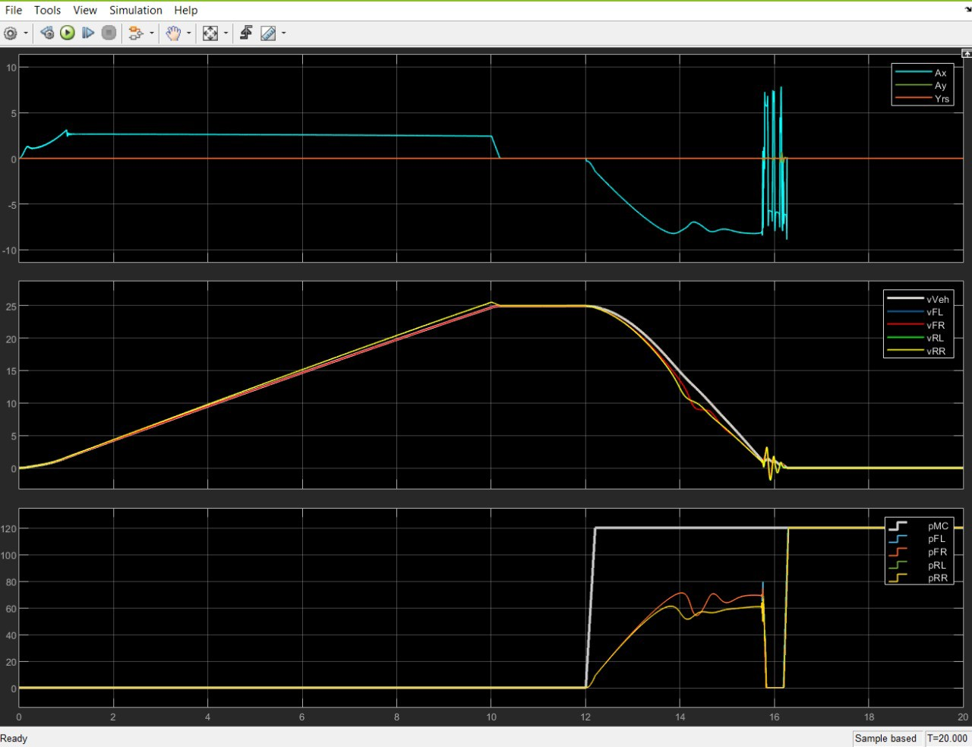

Figure 5: Scope graph in Simulink of T3

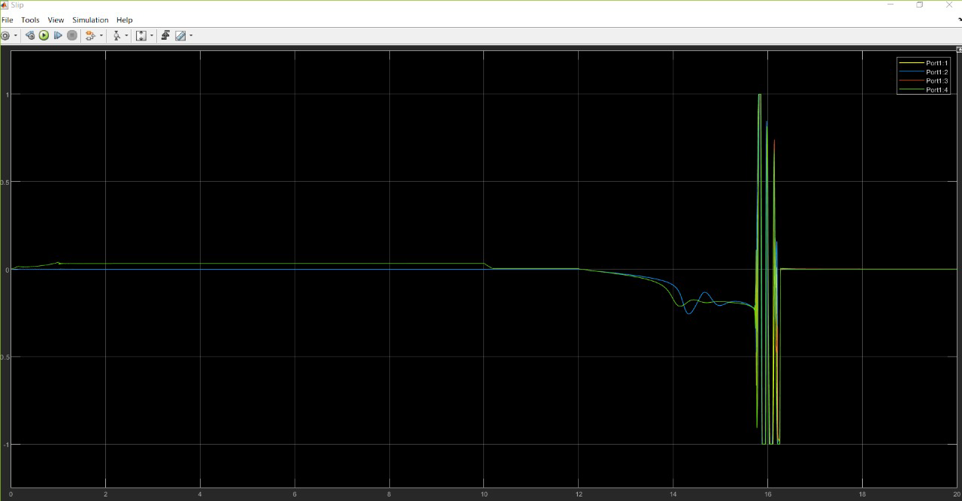

Figure 6: Slip Graph in Simulink of the T3

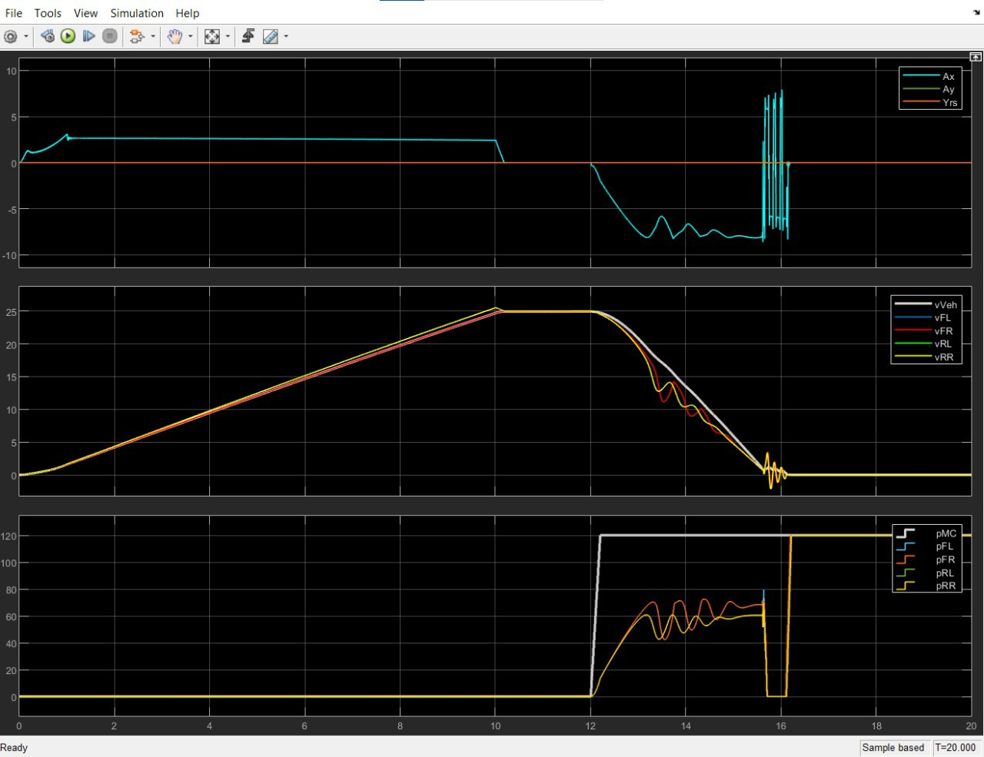

Figure 7: Scope graph in Simulink of the T4

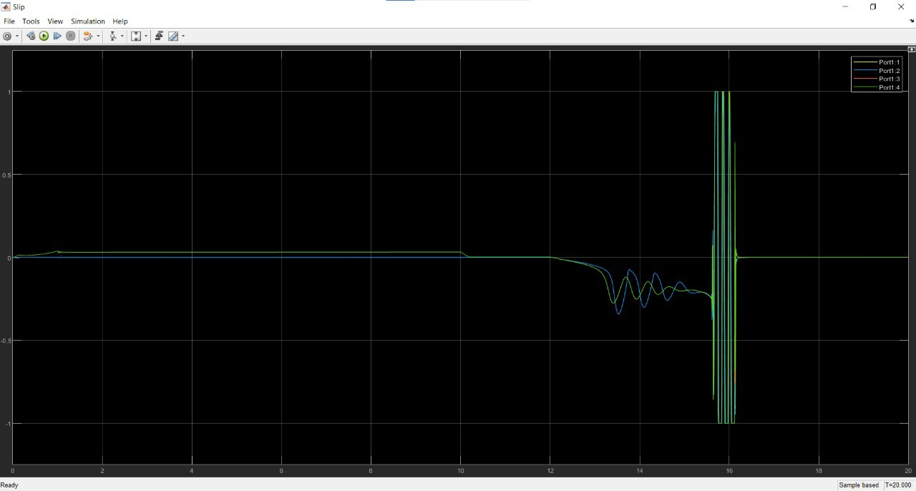

Figure 8: Slip graph in Simulink of the T4

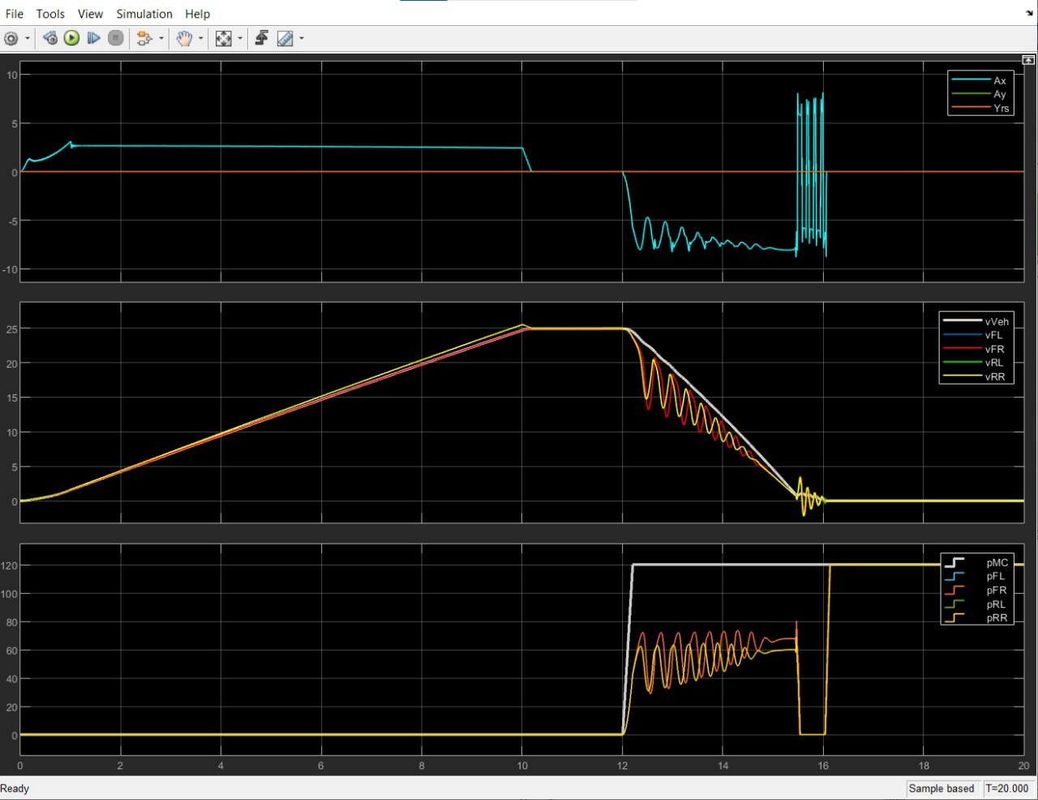

Figure 9: Scope graph in Simulink of the T5

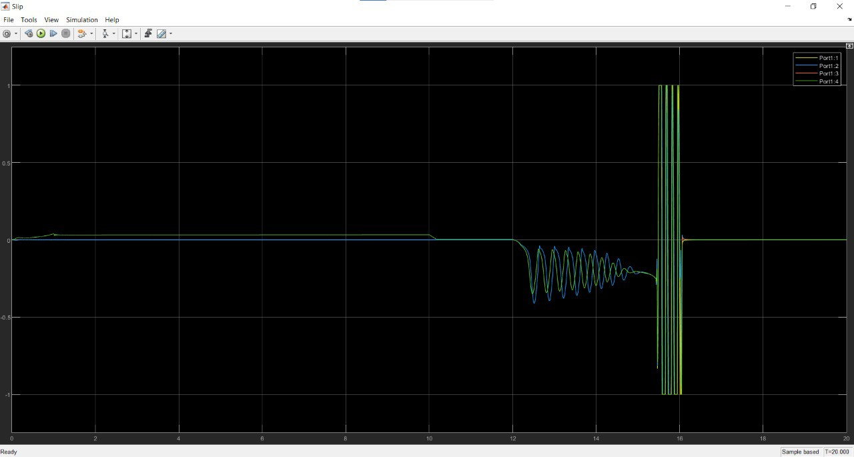

Figure 10: Slip graph in Simulink of the T5

## InitLightAndPanic70.m

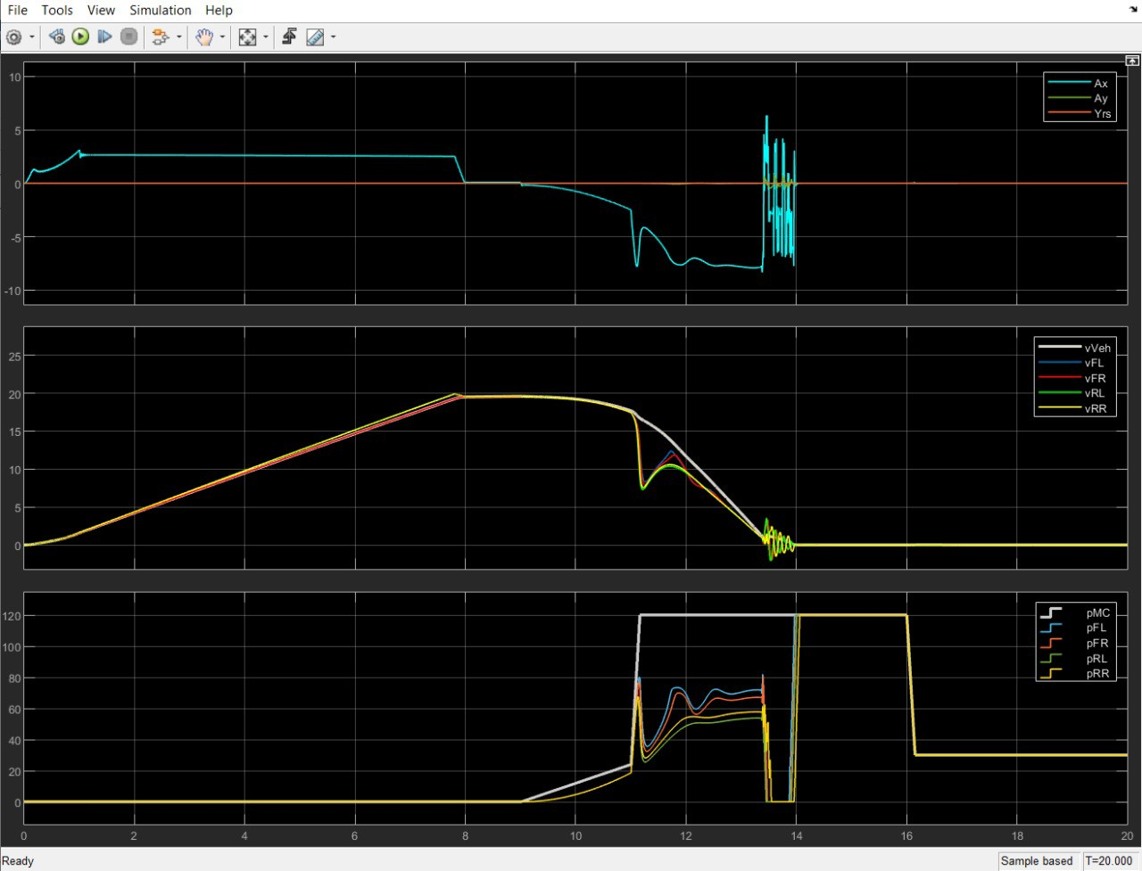

Figure 11: Scope graph in Simulink of the T3

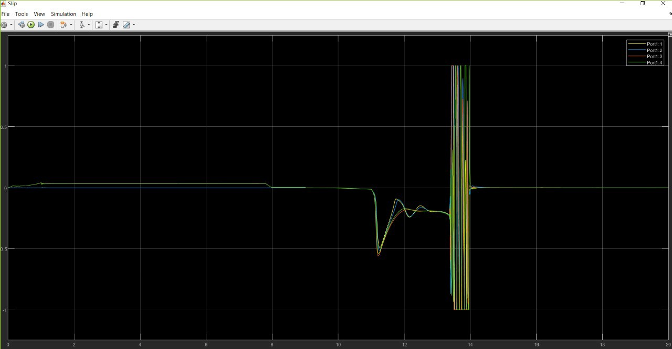

Figure 12: Slip graph in Simulink of the T3

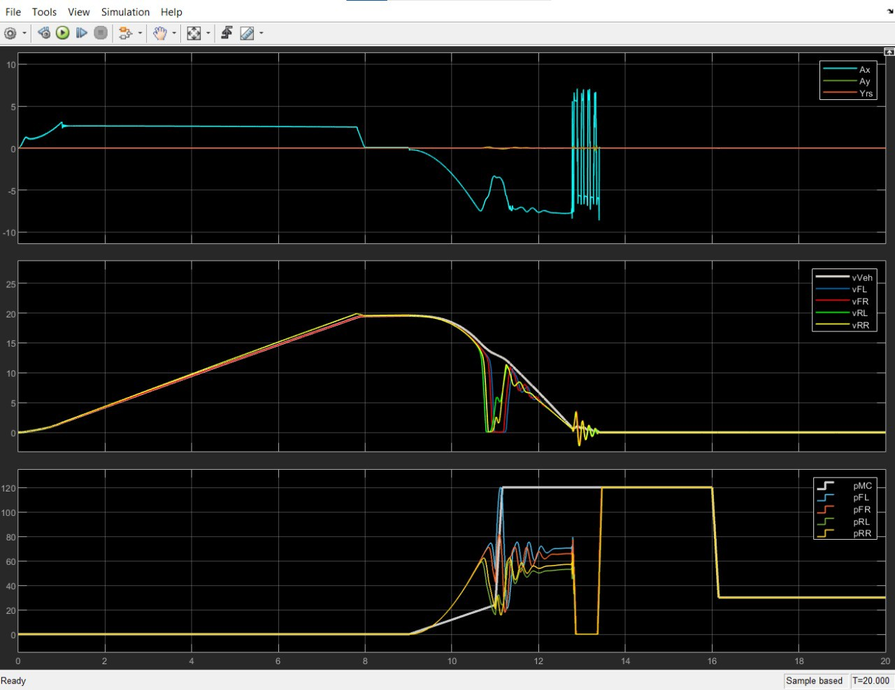

Figure 13: Scope graph in Simulink of the T5

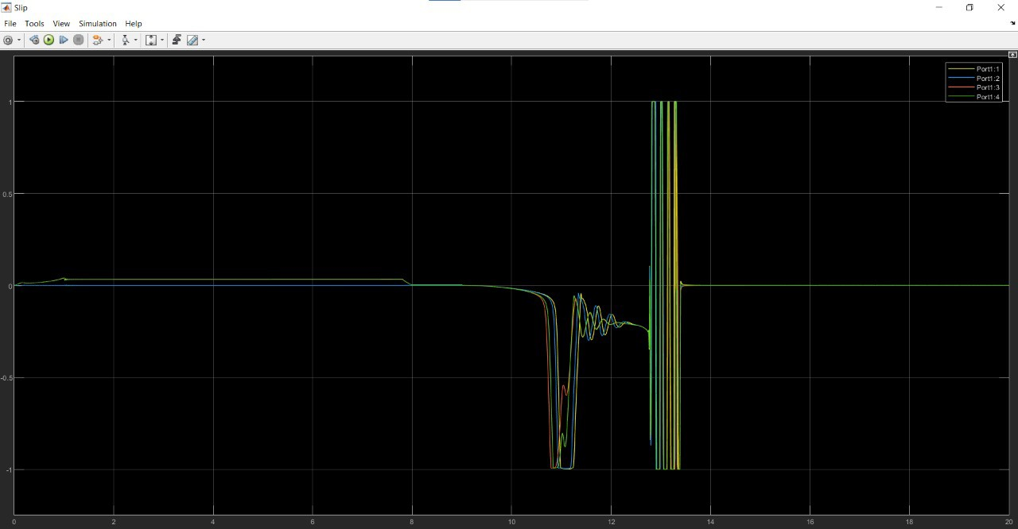

Figure 14: Slip graph in Simulink of the T5

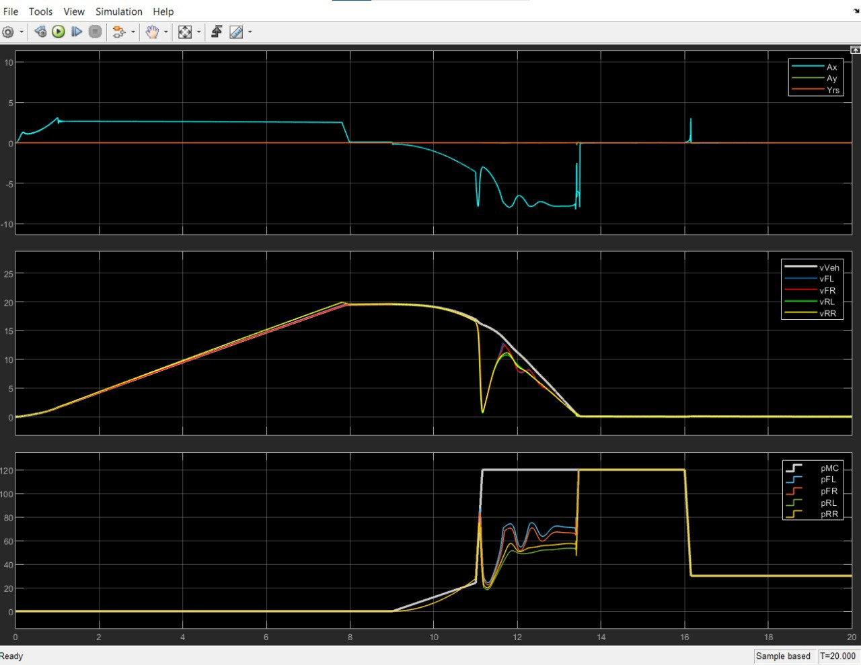

Figure 15: Scope graph in Simulink of the T4

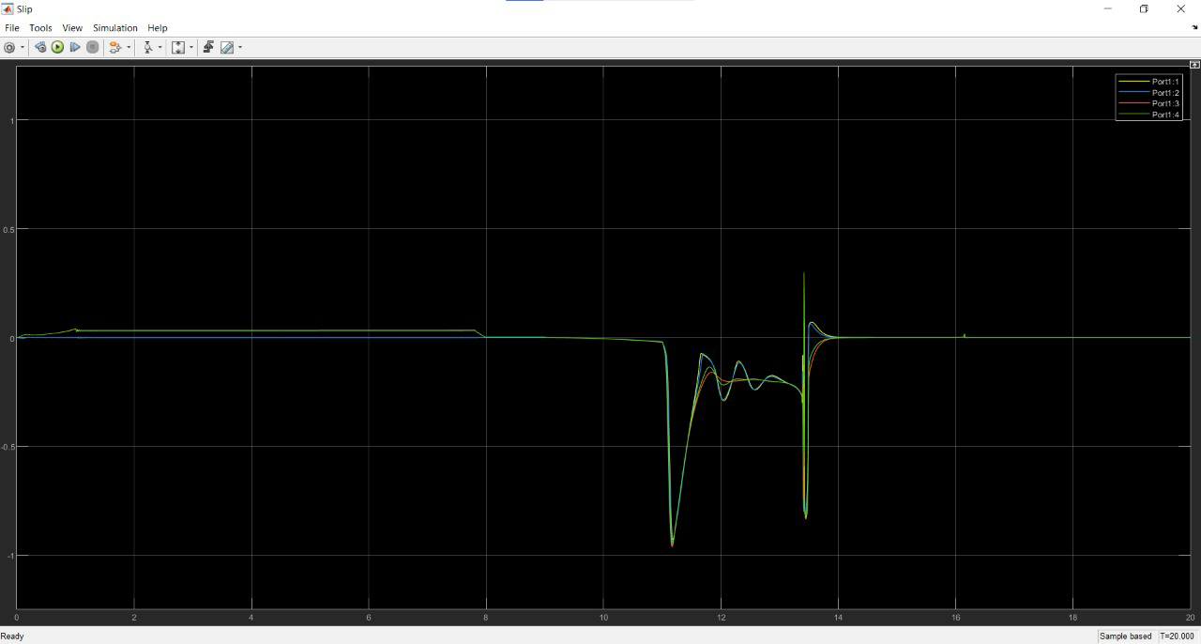

Figure 16: Slip graph in Simulink of the T4

## InitHighLow70.m

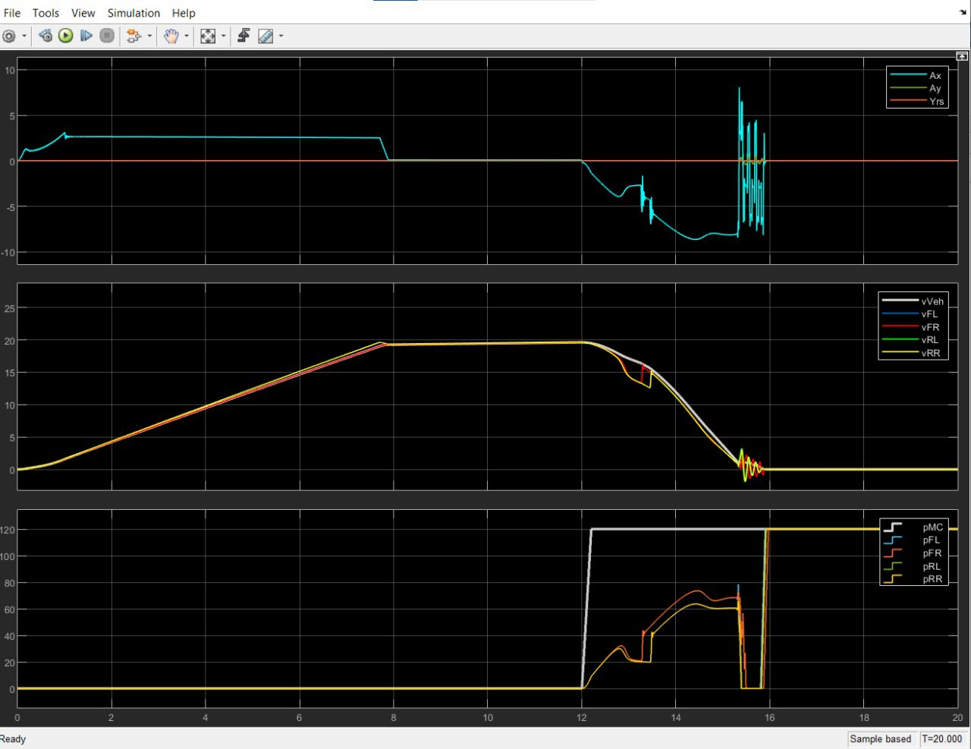

Figure 17: Scope graph in Simulink of T3

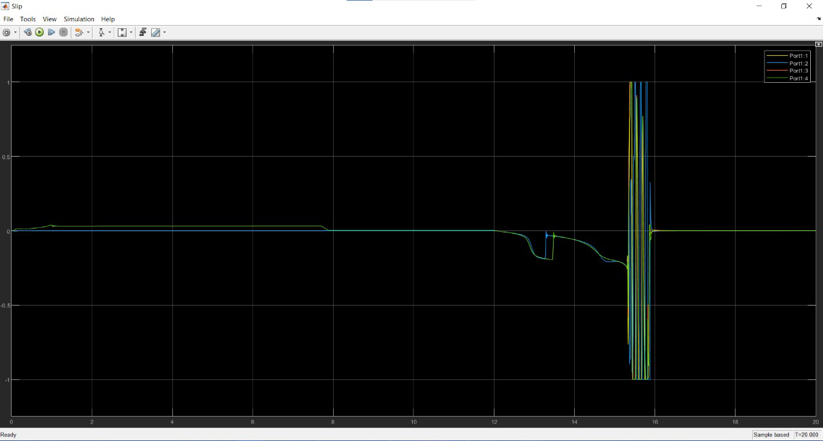

Figure 18: Slip graph in Simulink of T3

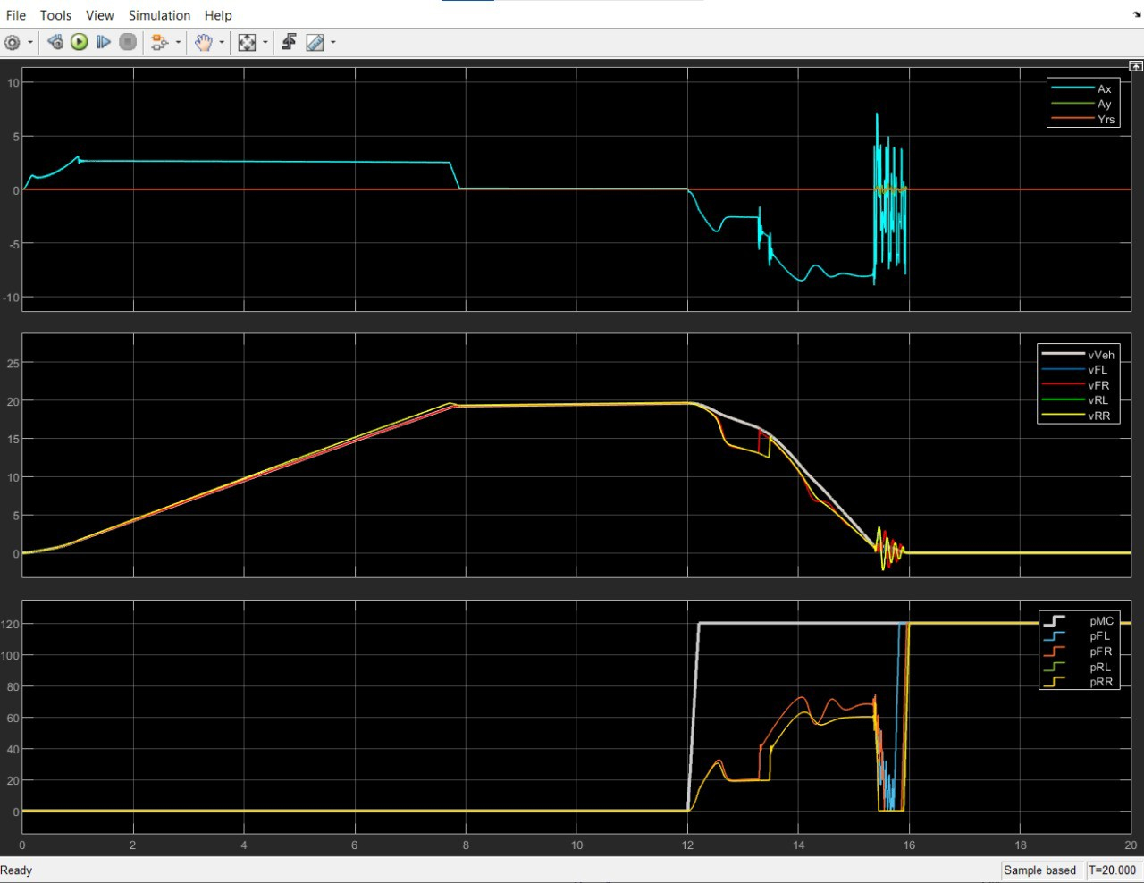

Figure 19: Scope graph in Simulink of T4

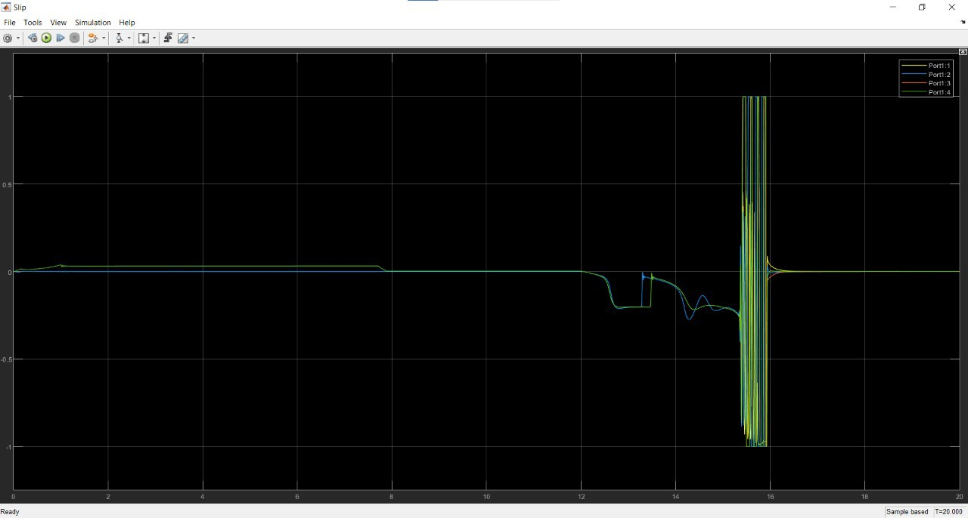

Figure 20: Slip graph in Simulink of T4

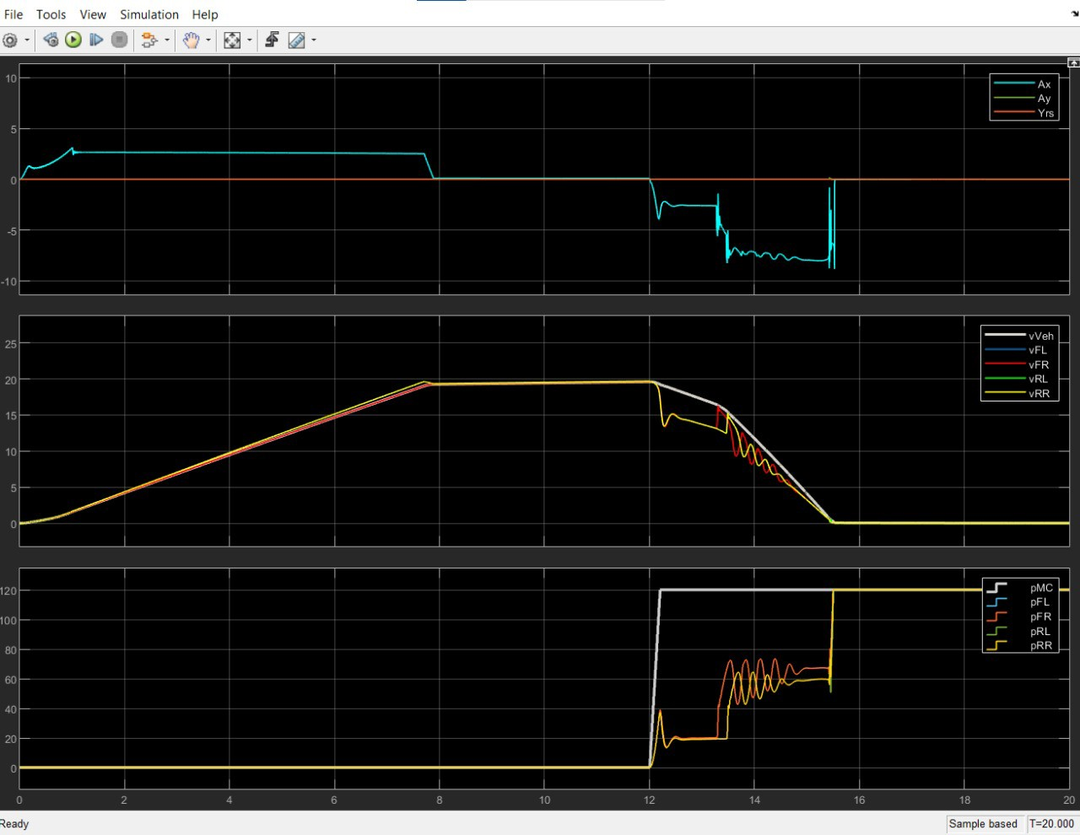

Figure 21: Scope graph in Simulink of T5

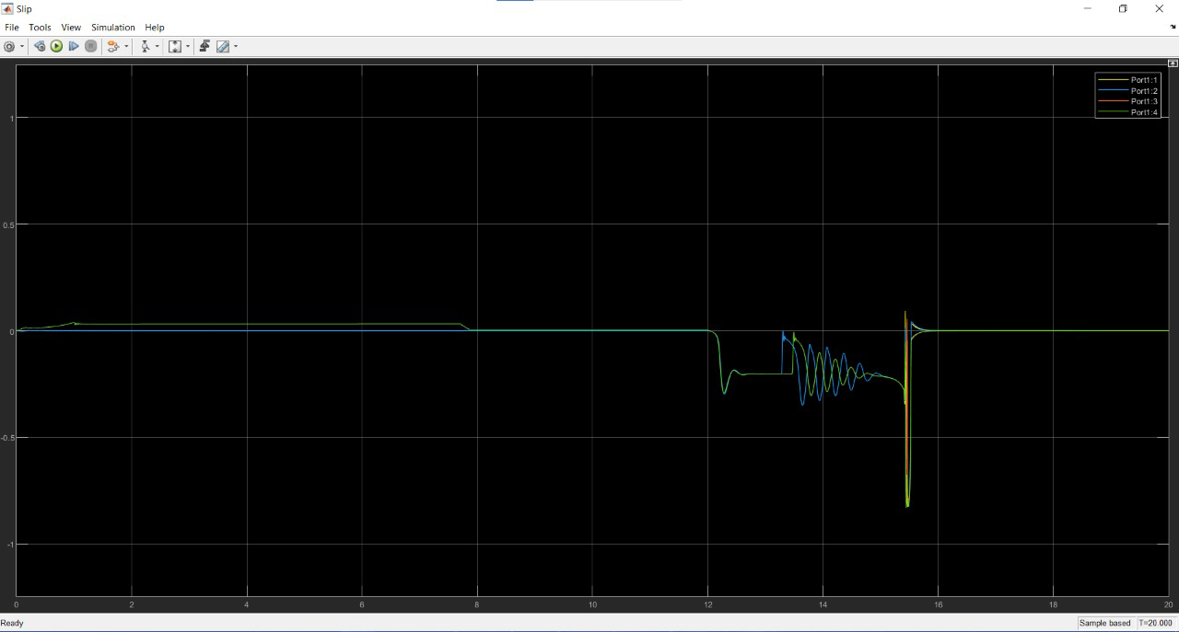

Figure 22: Slip graph in Simulink of T5

# Analysis of Results

For simplicity, for the three cases we analyzed we decided to use the same parameters in the PID controller and the same desired slip value; the results we obtained in each test were the following:

## InitPanic90.m

The values we obtained in the T5 attempt were the best, resulting in:

* + - Braking time: 4.04 seconds.
    - Braking distance: 48 meters.

If we compare these results to the test we performed without ABS, we can observe a 53% improvement in braking distance. The results obtained are explained in the graphs for attempt T5 below.

In the Scope graph shown in Figure 9, at the beginning of braking (approximately at second 12), pressure is applied to MC, the controller's action keeps this pressure below that applied by the driver; in this way, it is optimized to maintain the desired slip and reduce speed in a shorter time.

Therefore, in the Slip graph shown in Figure 10, at the start of braking, the slip starts to increase until the controller action is set at an average value of 0.2 (desired value) and subsequently, as the car brakes, there is no more slip.

## InitLightAndPanic70.m

The values we obtained in the T4 attempt were the best, resulting in:

* + - Braking time: 4.55 seconds.
    - Braking distance: 60.16 meters.

If we compare these results to the test we performed without ABS, we can observe a 38% improvement in braking distance. The results obtained are explained in the graphs for attempt T4 below.

In the Scope graph shown in Figure 15, at the start of light braking (approximately second 9), an equivalent pressure is applied at MC, and then, around second 11, the panic brake pressure is applied. The controller's action keeps this pressure below that applied by the driver; in this way, it is optimized to maintain the desired slip and reduce speed in a shorter time.

Therefore, in the Slip graph shown in Figure 16, at the beginning of braking, the slip starts to increase until the controller action is set at an average value of 0.2 (desired value) and subsequently, as the car brakes, there is no more slip.

It is worth noting that the best attempt was T5, due to the fact that it braked in a shorter distance and time; however, the graph showing the pressure applied to the brake calipers in Figure 13 shows that at a certain point, the pressure applied to the calipers exceeds the pressure applied by the driver to the master cylinder, which is the established limit. For this reason, we decided to place attempt T4 as the best in this test.

## InitHighLow70.m

The values we obtained in the T5 attempt were the best, resulting in:

* + - Braking time: 3.96 seconds.
    - Braking distance: 42.27 meters.

If we compare these results to the test we performed without ABS, we can observe a 40% improvement in braking distance. The results obtained are explained in the graphs for attempt T5 below.

In the Scope graph shown in Figure 21, at the start of braking (approximately at second 12), pressure is applied to MC. The controller's action keeps this pressure below that applied by the driver; in this way, it is optimized to maintain the desired slip and reduce speed in a shorter time.

Therefore, in the Slip graph shown in Figure 22, at the start of braking, the slip starts to increase until the controller action is set at an average value of 0.2 (desired value) and subsequently, as the car brakes, there is no more slip.

# Conclusions

Based on the progress made in developing our proposal for the anti-lock braking system and the results of the various tests, as well as the resolution of the obstacles we encountered, we can conclude the following:

1. *Selecting an inappropriate slip reference can seriously impair system performance.*

In our particular case, the reference value for slip was initially selected as too low, which caused us many problems not only with the performance of the system and the significant increase in braking time and distance, but also with the stability of the vehicle, since by maintaining such a low slip, the system was not able to adhere to the road in the best way, so changes in the friction coefficients for each wheel generated a yaw in the vehicle, so even before modifying this reference, we had contemplated adding a control algorithm for the turn when in reality for the requested tests it was not yet necessary, since said turn could be corrected simply by adjusting said reference.

1. *Driver constants have a big impact on performance.*

We were able to corroborate from the sweep we performed to select the most appropriate Kp, Ti and Td constants for our system, that the simple modification of one of the variables or the adjustment of the relationship between them brought considerable changes in the system performance, being able to reduce or increase considerably, depending on the case, the braking time and distance. Furthermore, as previously mentioned, we had to adjust the constants selected in the fifth attempt at the last attempt and resume those used in the fourth attempt, since the change in the constants between both attempts, although they brought an improvement in the braking parameters, caused one of the requirements to no longer be met. Therefore, the selection of the appropriate constants and being aware of all the changes produced by their adjustments is of vital importance.

Finally, as areas of opportunity for our system, we consider that:

* + In the future, and to improve the response of our system to the different tests, we could consider variables that were not considered on this occasion and that can be obtained as far as possible from the vehicle model, such as aerodynamic conditions, the vehicle's drive axle or even the distribution of braking between axles, aspects that could bring an improvement to the braking parameters of our design.
  + Reduction of slip oscillations at speeds very close to zero. While they do not have a major impact on the system's braking parameters as the vehicle is practically stationary, the ideal would be to at least reduce, if not completely eliminate, these oscillations.
  + Replacement or complement of the control algorithm used, being able to apply alternatives such as neural networks or controllers based on fuzzy logic.